DAY -3

ZECPATH AI

Project Prepared By Suhail TP

Zecpath AI – Day 3 Deliverables

Objective
To establish a professional AI development environment and scalable modular repository structure for the Zecpath AI ATS Engine module.

1.Virtual Environment Setup

• Python 3 installed and verified.
• Virtual environment created using: python3 -m venv zecpath_env
• Environment activated using: source zecpath_env/bin/activate
• Required libraries installed: pytest, pandas

2. Modular Folder Structure

zecpath-ai/
│
├── ats_engine/
│ ├── __init__.py
│ └── ats_scoring.py
├── parsers/
├── screening_ai/
├── interview_ai/
├── scoring/
├── utils/
│ └── logger.py
├── tests/
│ └── test_ats.py
├── main.py
└── README.md

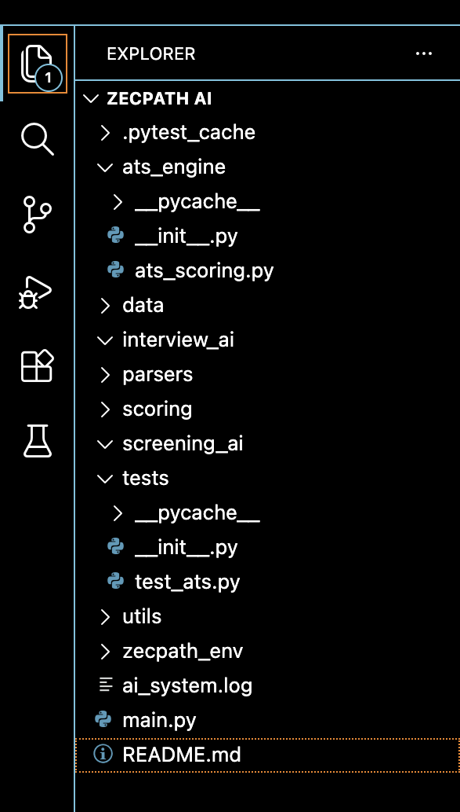

3. ATS Scoring Engine Implementation

File: ats_engine/ats_scoring.py
Scoring Formula: Score = (Skill Match × 10) + Experience

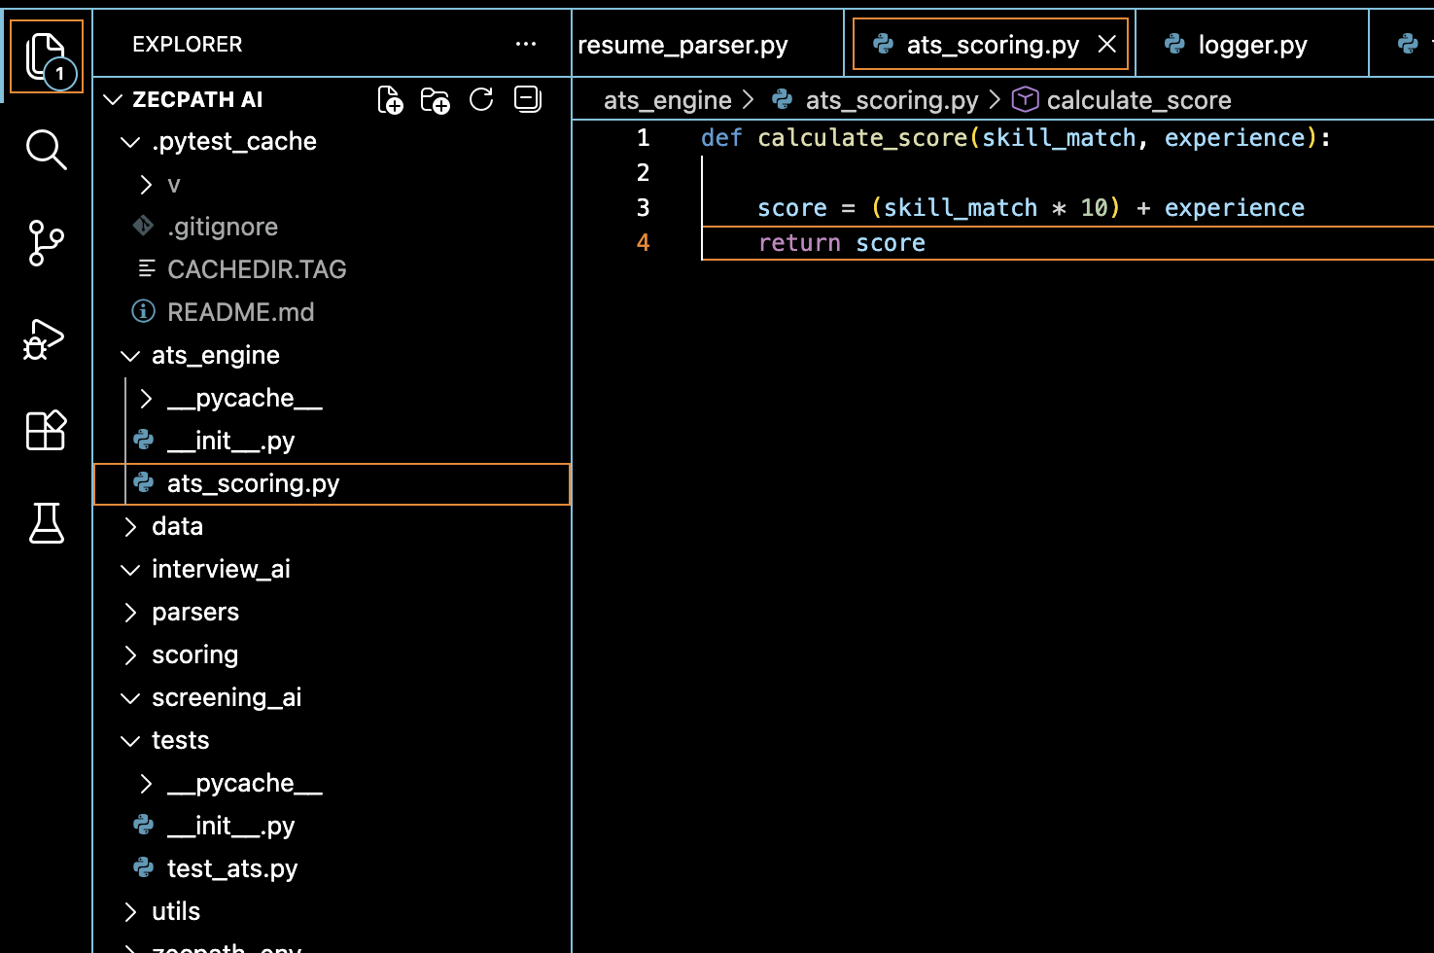

4. Execution Entry (main.py)
File: zecpath-ai/main.py

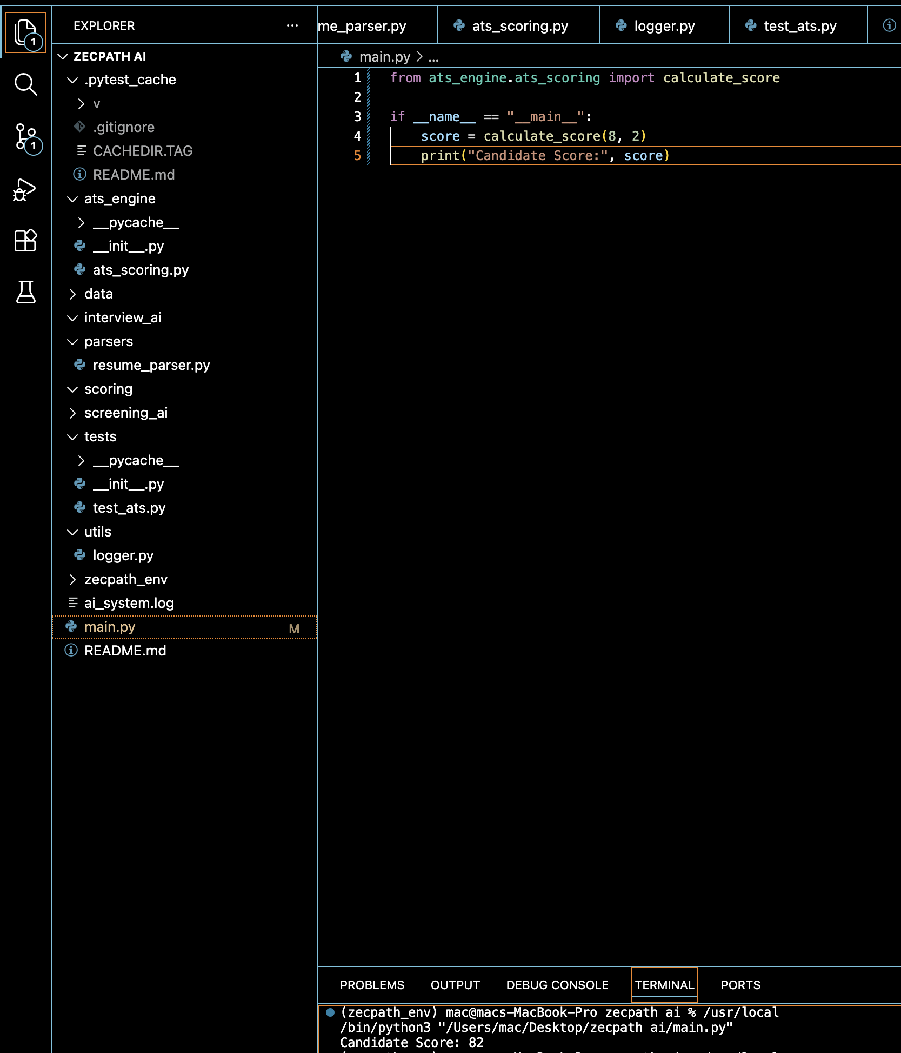

5. Logging System

File: utils/logger.py

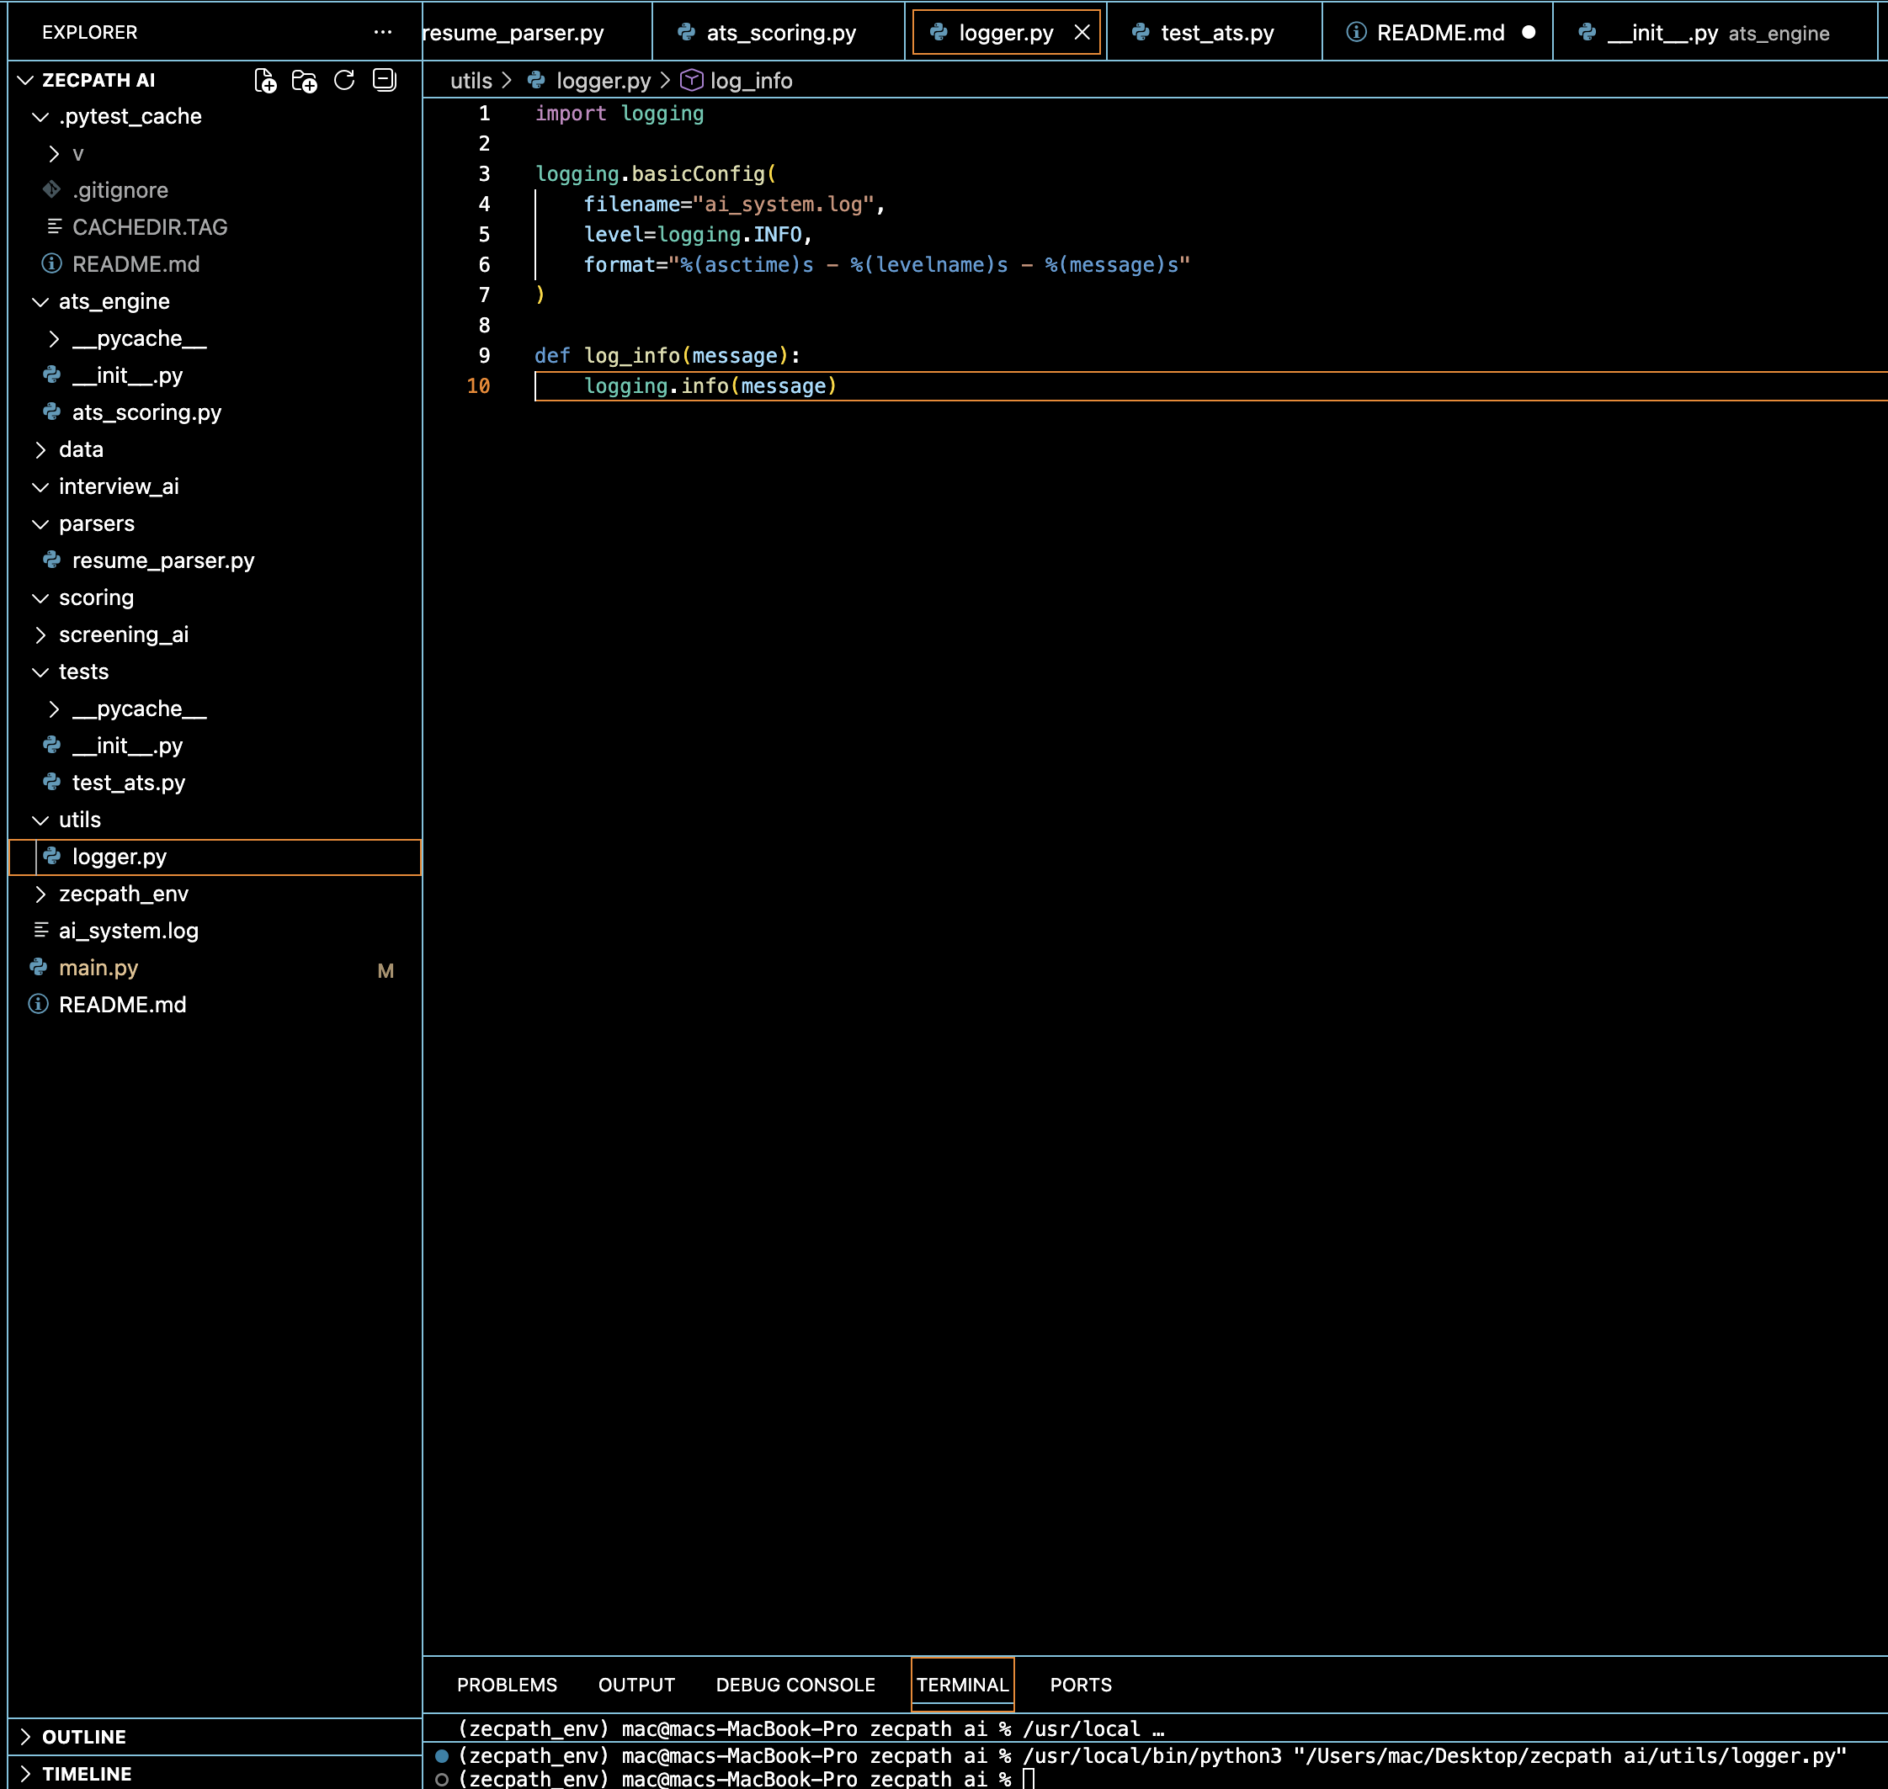

6. Unit Testing

File: tests/test_ats.py

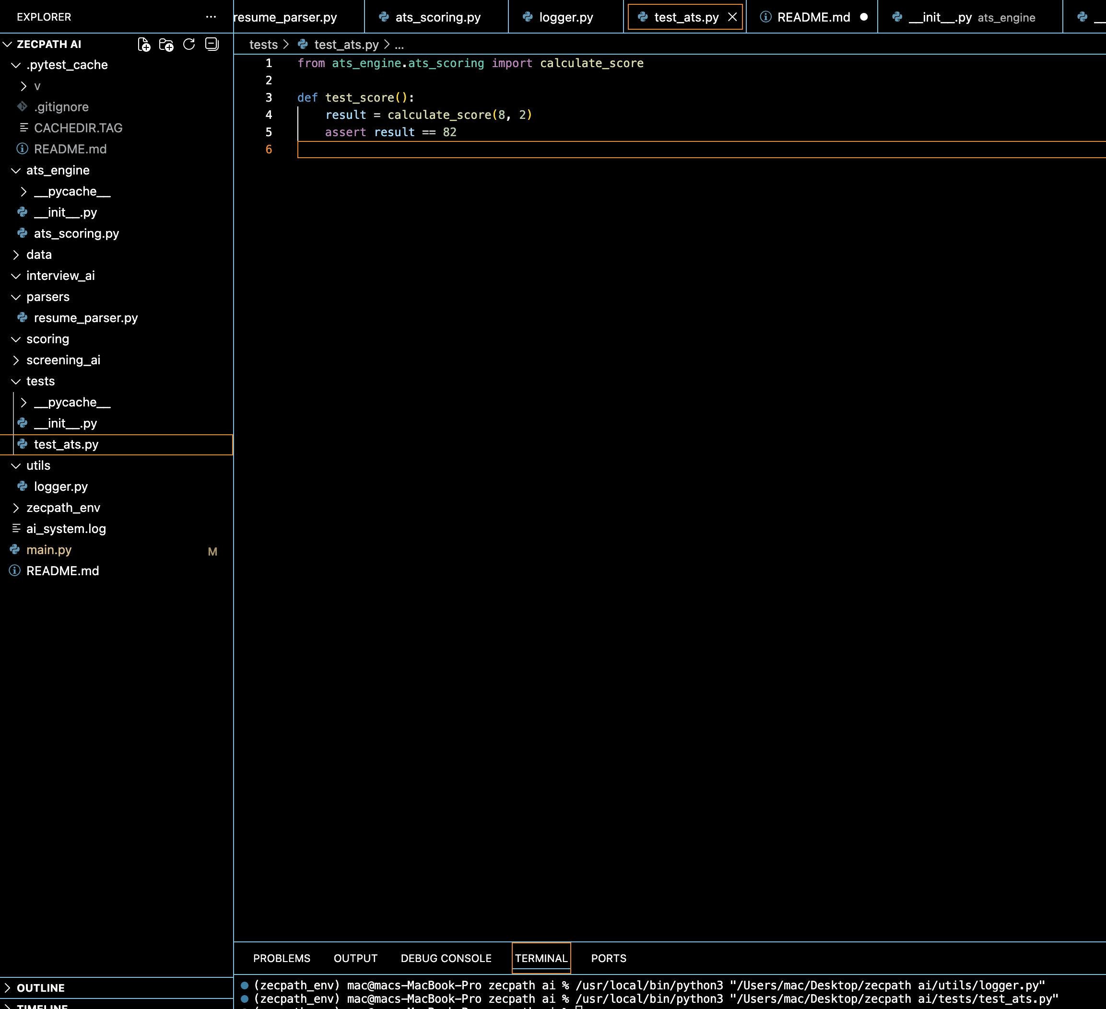

7. AI Repository

Link : https://github.com/suhailpzb/zecpath-ai.git

8. README

Link : https://github.com/suhailpzb/zecpath-ai/blob/3c6ee2aa4fb8c2aebdee32b8641b02af5bedae3d/README.md

Conclusion

The Day-3 deliverables successfully establish a scalable, modular, and testable ATS Engine microservice within the Zecpath AI architecture.

